IXL Instructions
How to access online assignments on IXL

Step 1: Go to: www.ixl.com/signin
Type in student username and password (Please email your child’s teacher if you do not have login info.)
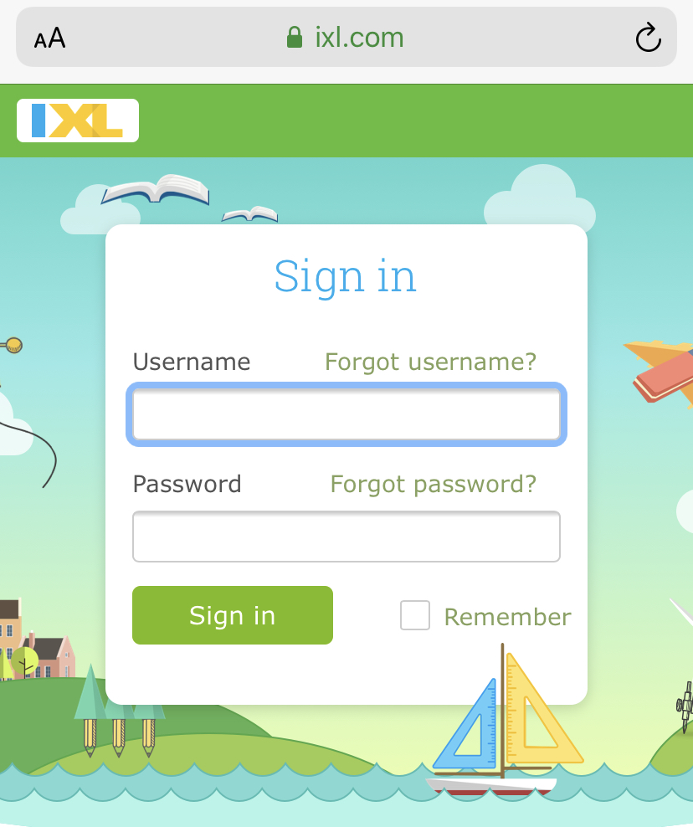

Step 2: Class subjects will appear at the top.
Select assigned subject
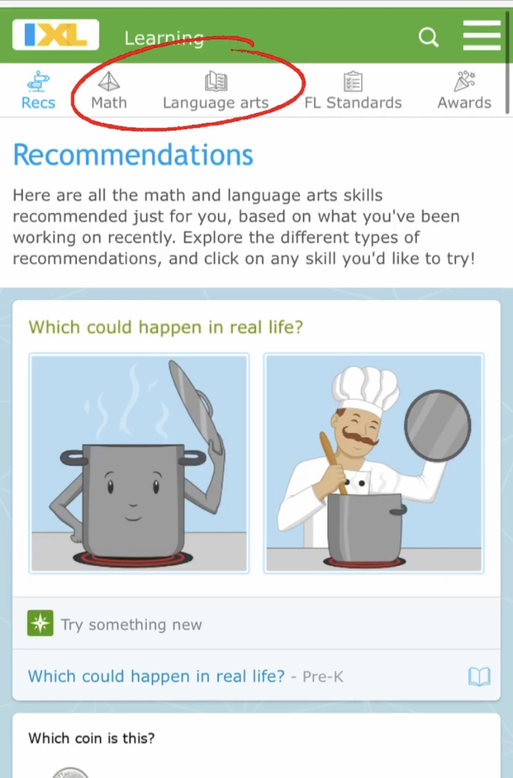

Step 3: Select “Skill Plans”
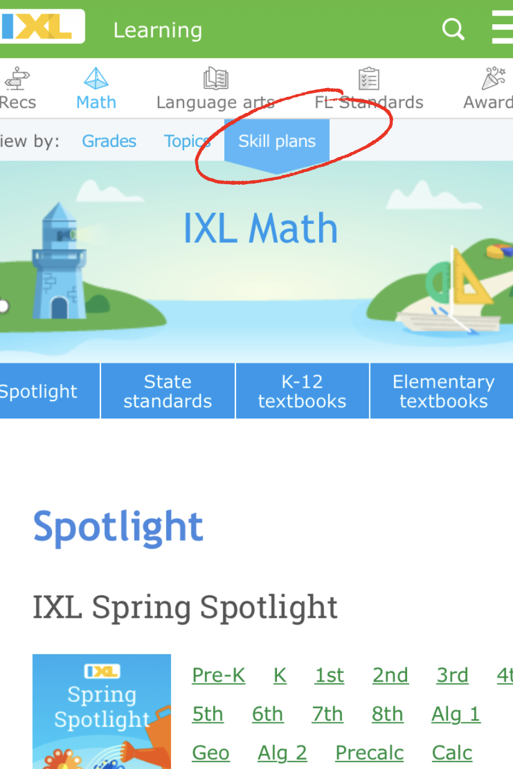

Step 4: Under IXL Spring Spotlight select child’s grade

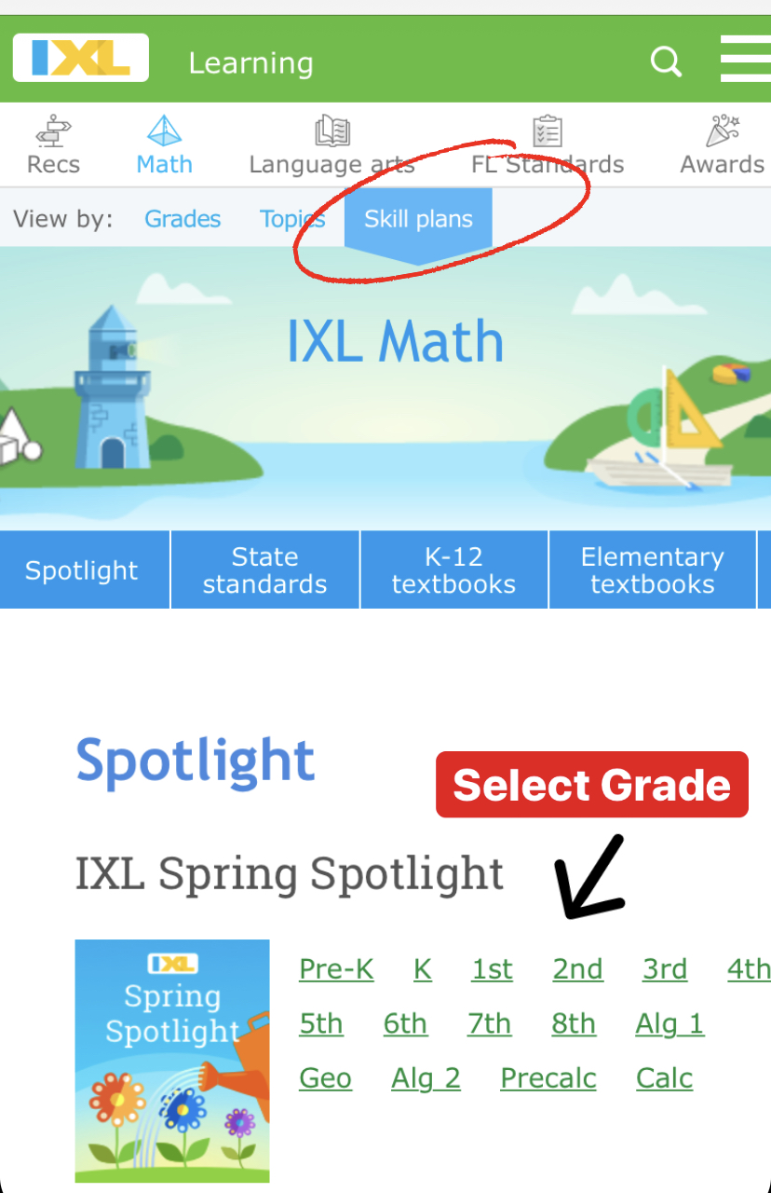

Step 5: Assignments are organized by week. Complete the assignments only for the week and day assigned by your teacher (see online school schedule). Your smart score goal is 80 or higher
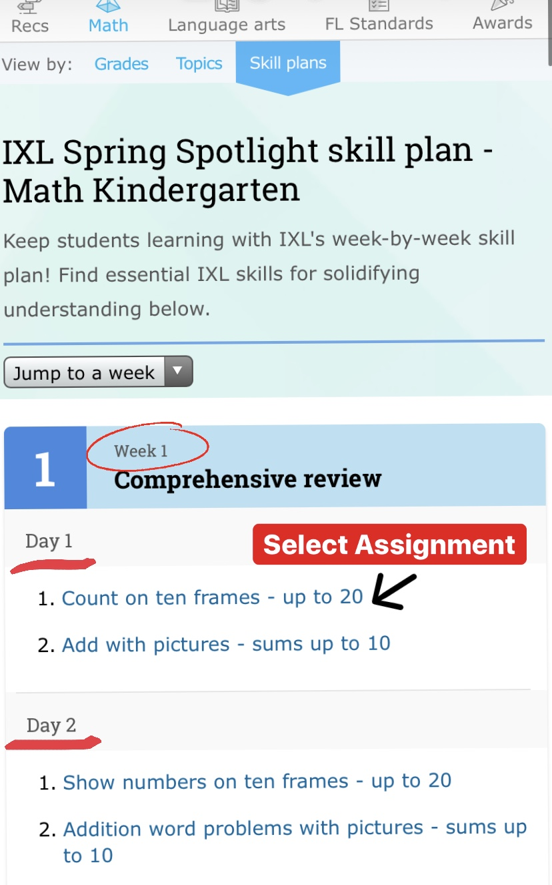

***Also available for download on the APP Store

Please note: Each question includes a “learn with example” option. This will allow your student to learn the same question with different numbers and step-by-step instructions.

